**AEM Author Portfolio Project – Simple Procedure**

**1. Create the Required Pages**

* Home Page → /content/author-portfolio/home.html
* About Me Page → /content/author-portfolio/about-me.html
* Awards Page → /content/author-portfolio/awards.html
* Books Page → /content/author-portfolio/books.html
* Individual Book Pages → /content/myTraining1/books0/twisted-love.html, etc.
* Contact Me Page → /content/author-portfolio/contact-me.html

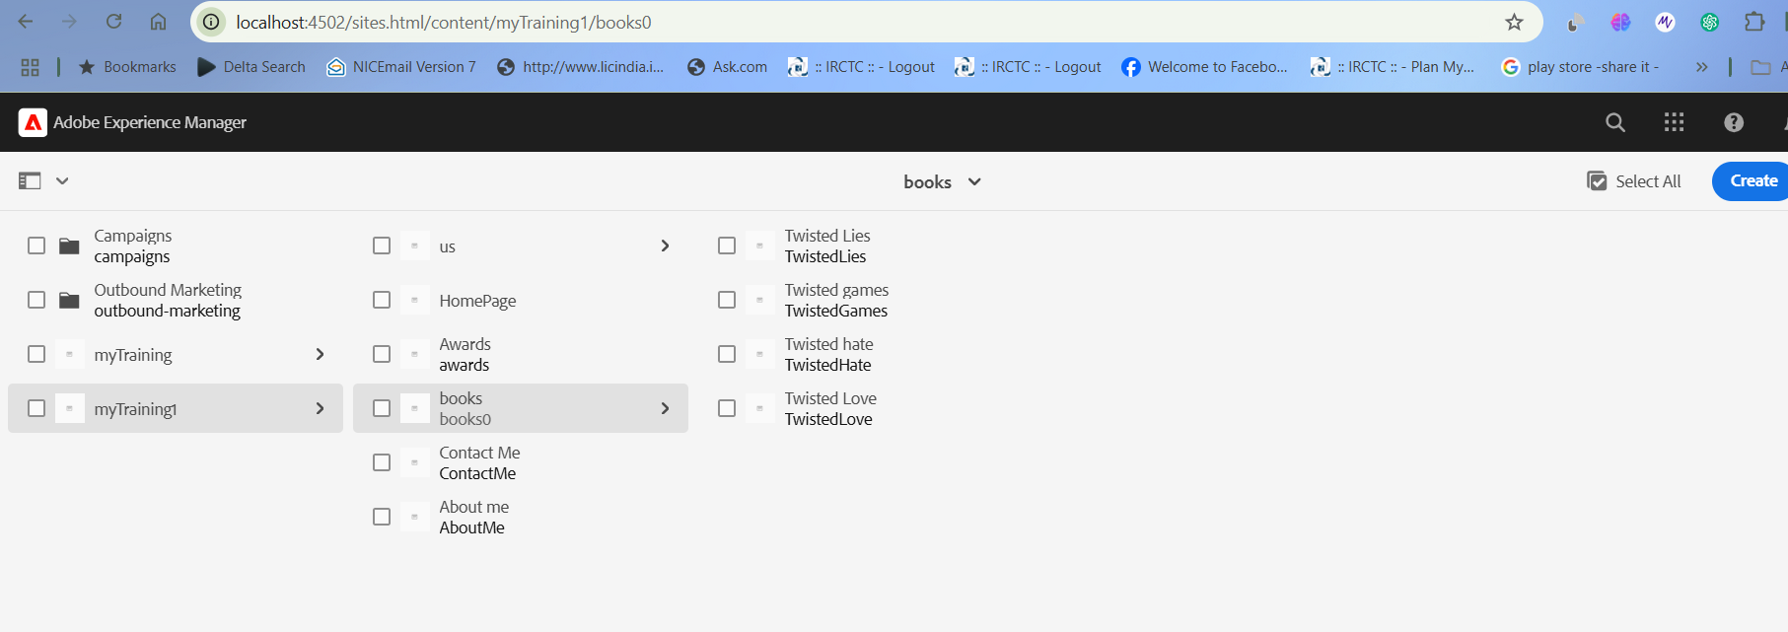

**2. Create Components**

Header (header.html)

* Displays navigation (Home, Books, About Me, Contact Me)
* Uses AEM's OOTB Navigation Component

Footer (footer.html)

* Displays About Me, Contact, Books List, Social Media
* Uses Text and List Components

Author Component (author.html)

* Displays Author Name, Image, DOB, Bio
* 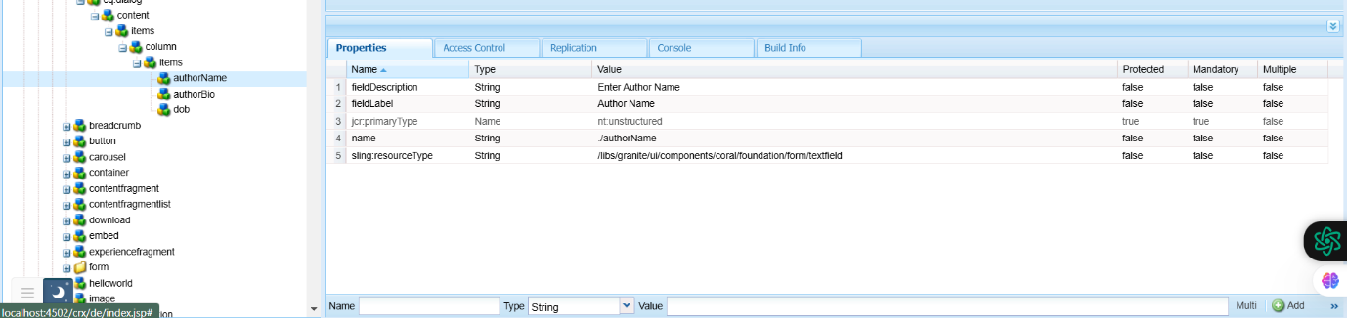

Book List Component (book.html)

* Dynamically fetches books from /content/myTraining1/books0
* Displays Book Cards (Title, Image, Description)

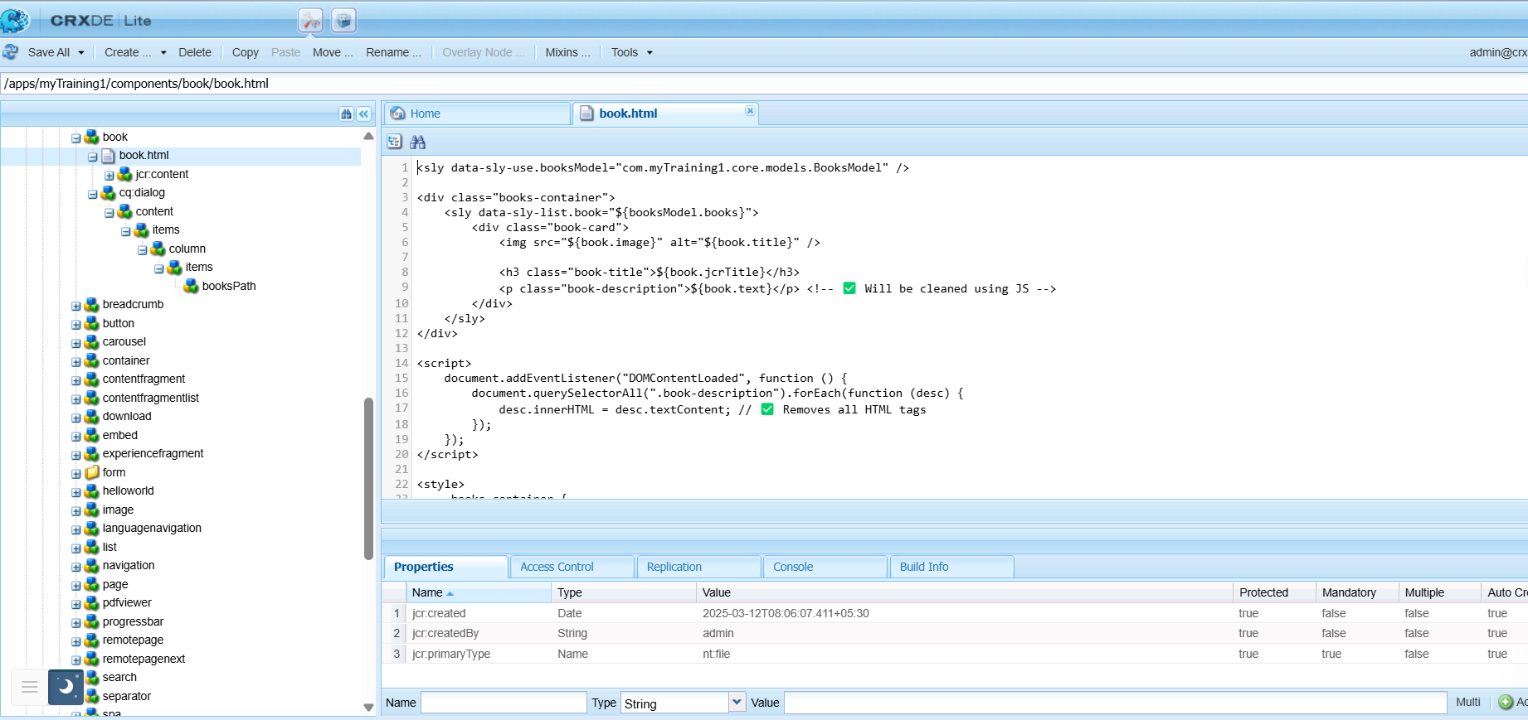

3. Organize Content in AEM

* Upload book images to DAM → /content/dam/myTraining1/books/
* Ensure all book pages are under /content/myTraining1/books0/

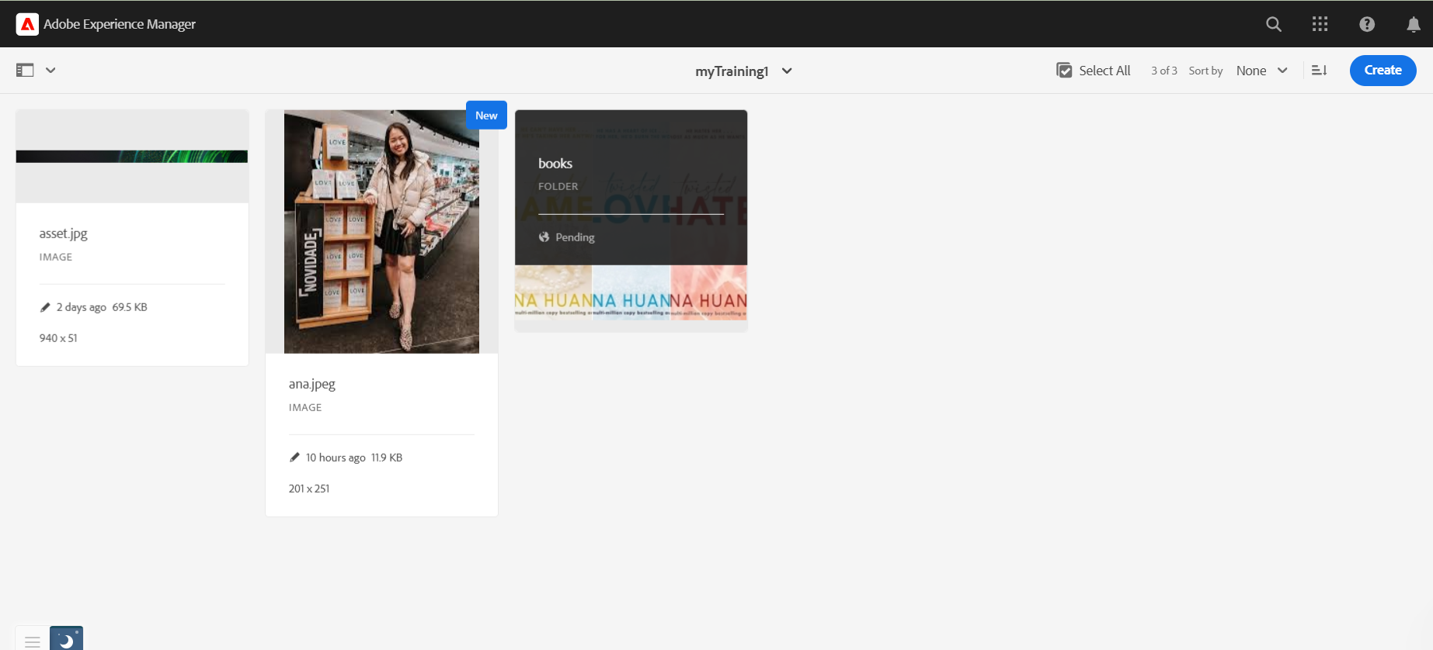

4. Deployment & Testing

1. Build the project using Maven:
2. mvn clean install -PautoInstallPackage
3. Check if pages load correctly in AEM:
4. http://localhost:4502/editor.html/content/author-portfolio/home.html
5. Verify book images load from DAM:
6. http://localhost:4502/content/dam/myTraining1/books/
7. Check logs for errors:
8. http://localhost:4502/system/console/slinglog

5. Final Steps

* Publish all pages and components
* Test the books list to ensure it dynamically fetches data
* Check the contact form submission